EXAM GUIDANCE

<https://secoit.sharepoint.com/sites/ExamNet/OCC/ExamGuidance/Forms/template.xsn>

Client:

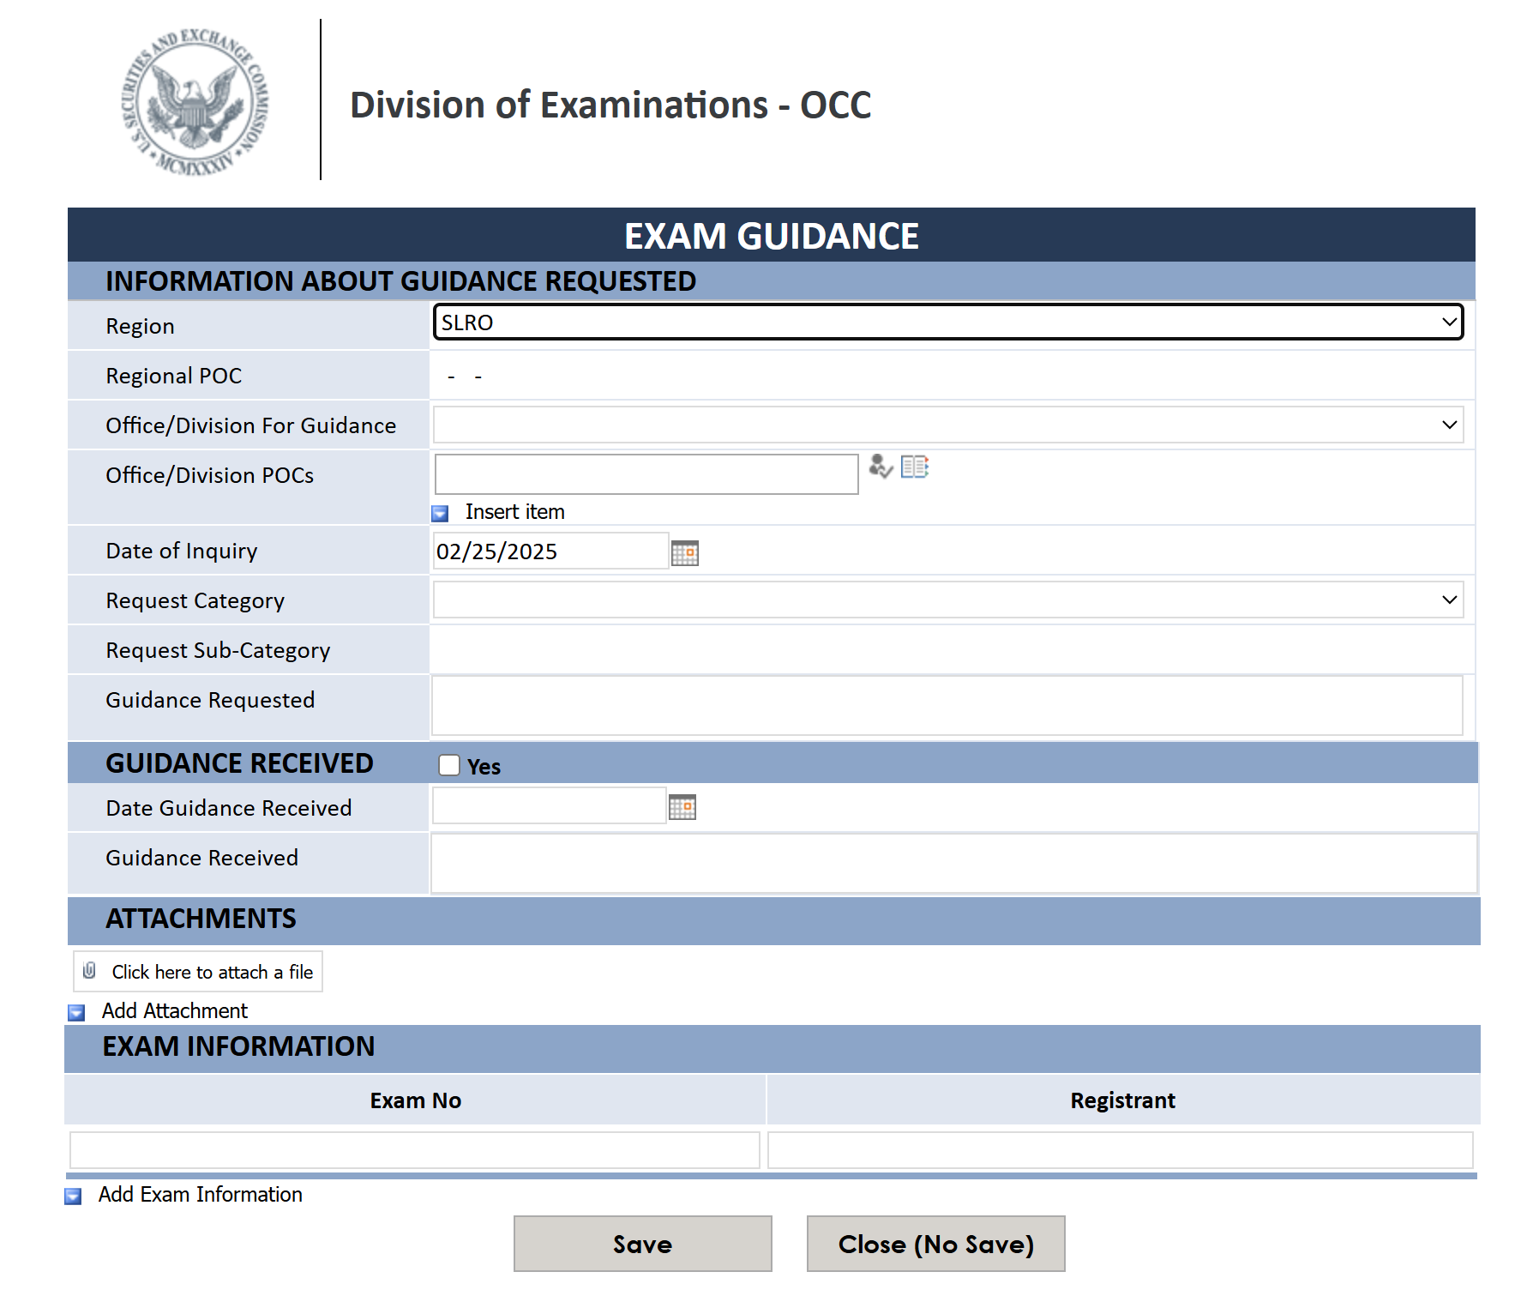

[EXAMS Exit Process - New Form](https://secoit.sharepoint.com/sites/ExamNet/me/BMO/_layouts/15/FormServer.aspx?XsnLocation=/sites/ExamNet/me/BMO/EXAMSExitProcess/Forms/template.xsn)

Client:

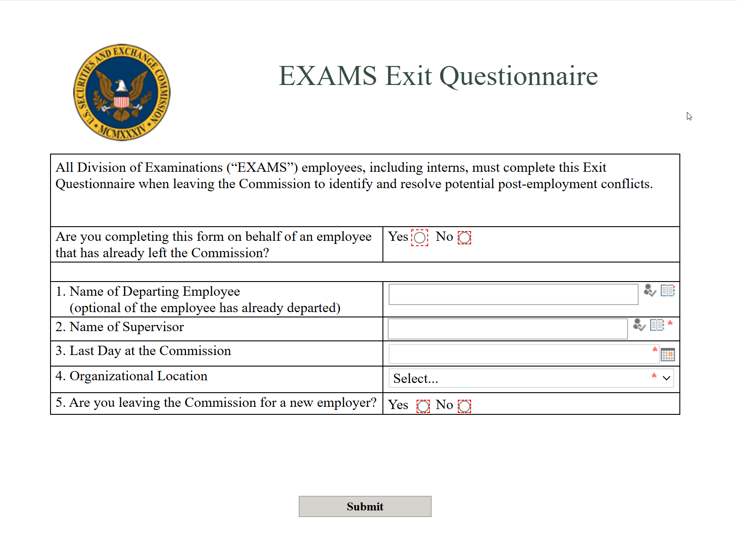

<https://secoit.sharepoint.com/sites/ExamNet/me/BMO/FacilitiesRequests/Forms/template.xsn>

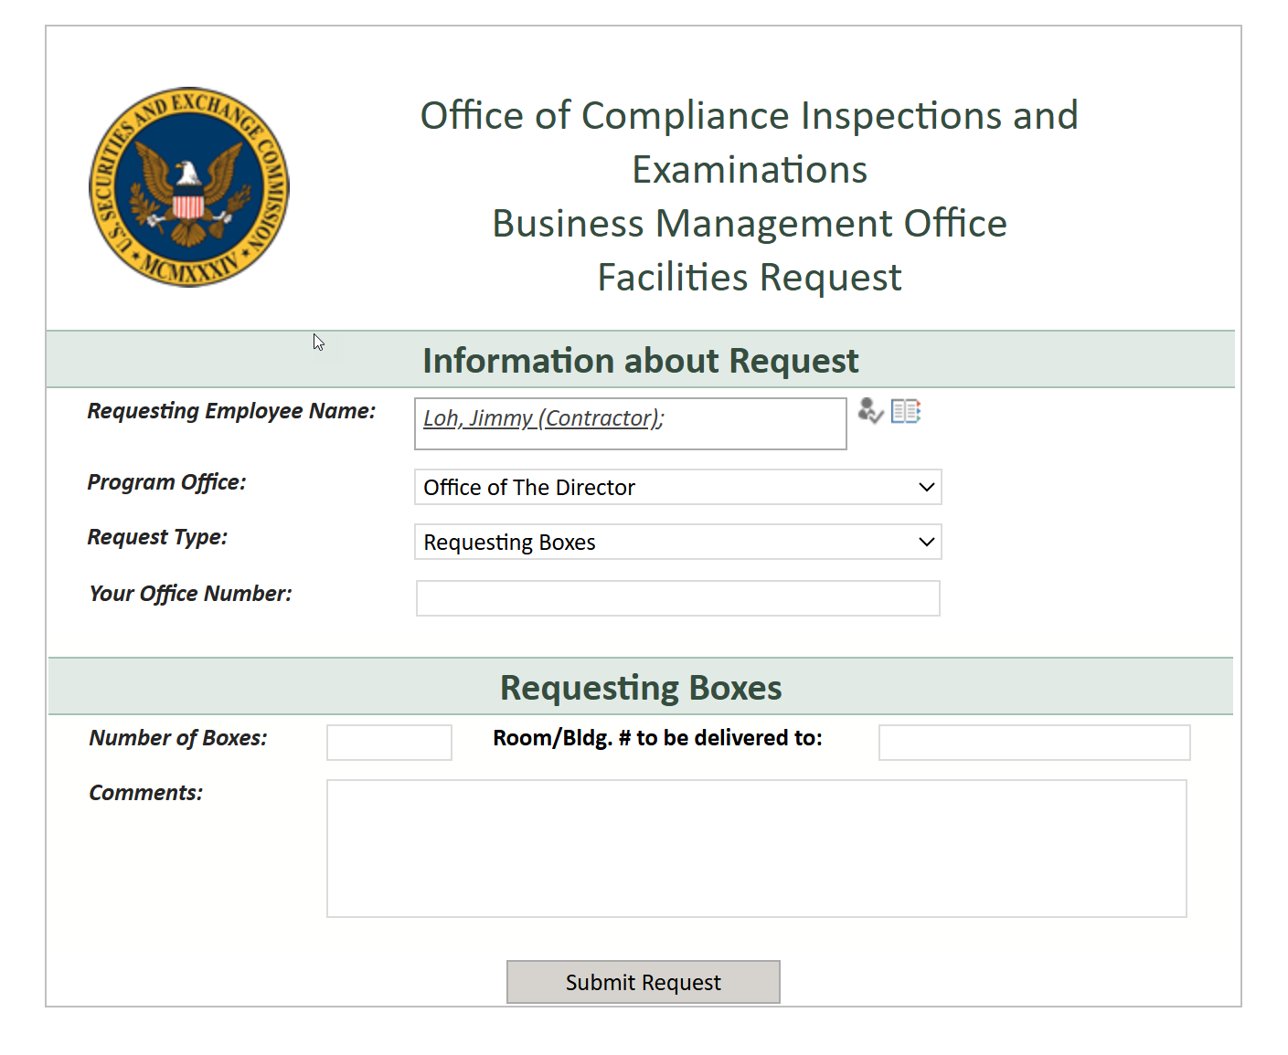

Cyber Watch

<https://secoit.sharepoint.com/sites/ExamNet/TCP/CW/BMIS/Lists/MasterListWeightedValues/Item/template.xsn>

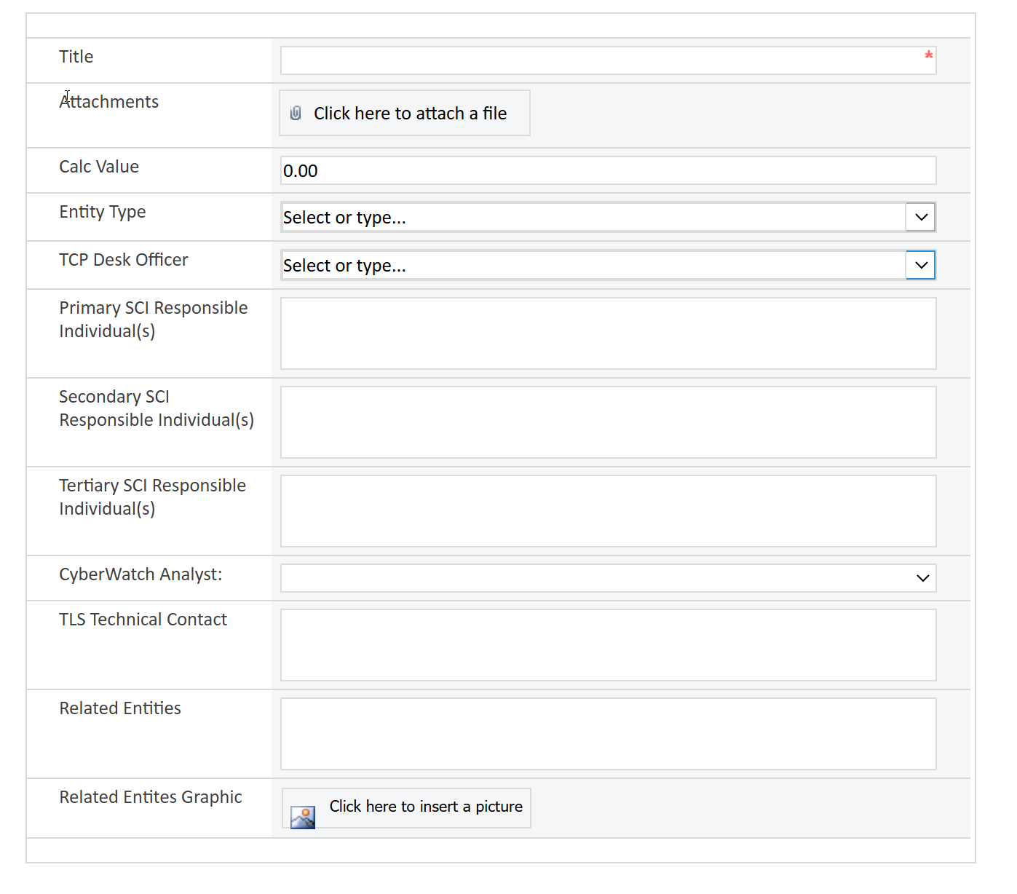

MASTER TABLE ENTRY

<https://secoit.sharepoint.com/sites/ExamNet/TCP/CW/BMIS/_layouts/15/FormServer.aspx?XsnLocation=/sites/ExamNet/TCP/CW/BMIS/Lists/Master%20List%20v2/Item/template.xsn>

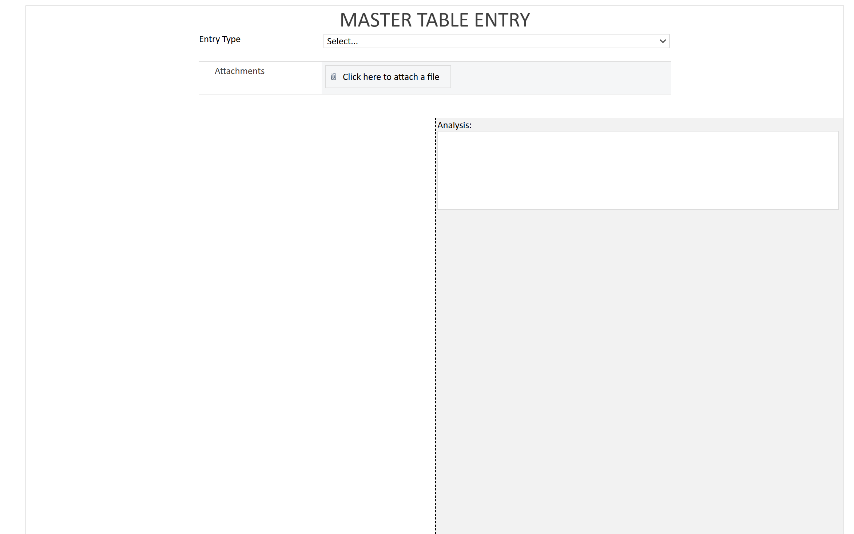

NYRO Outreach Event Participation Request

<https://secoit.sharepoint.com/sites/ExamNet/IAIC/NYRO/IA_IC/OutreachEvents/Forms/template.xsn>

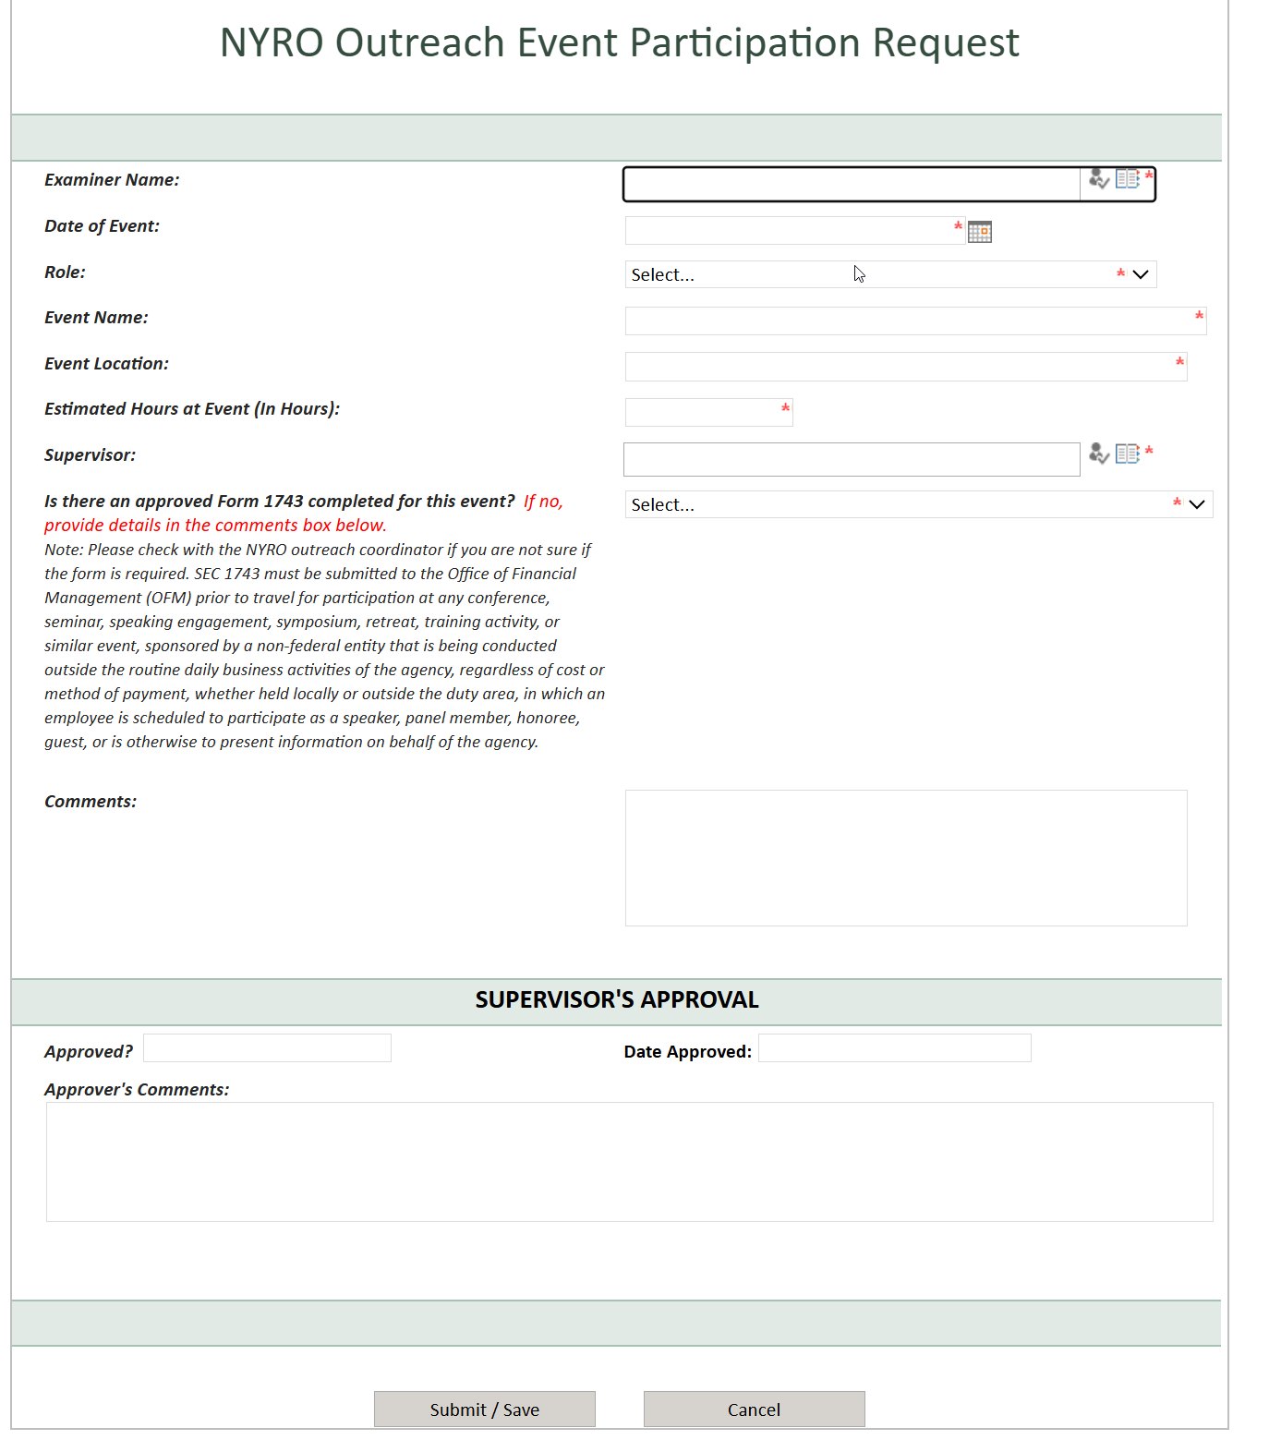

Registrations Branch - Review Audit List

<https://secoit.sharepoint.com/sites/ExamNet/ORS/rb/Lists/AuditList/Item/template.xsn>

